PYTHON PROJECT
MENU MANAGEMENT SYSTEM

Name: Arpit Saxena Enrolment No:151256
Batch-B2
Email Id: arpit.saxena591@gmail.com
Project: Menu Management System

Description:

THE MAIN PAGE:
The main page it consists of 4 Buttons:
a. Enter
b. Help
c. About us
d. Exit
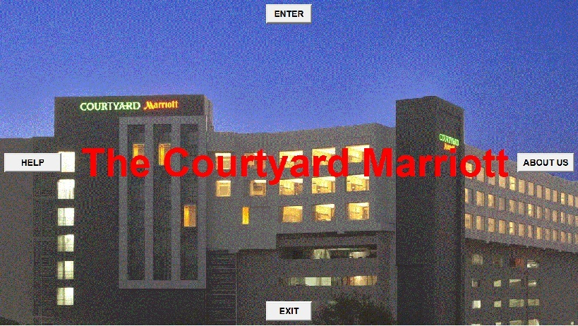

Now when we click on HELP BUTTON:

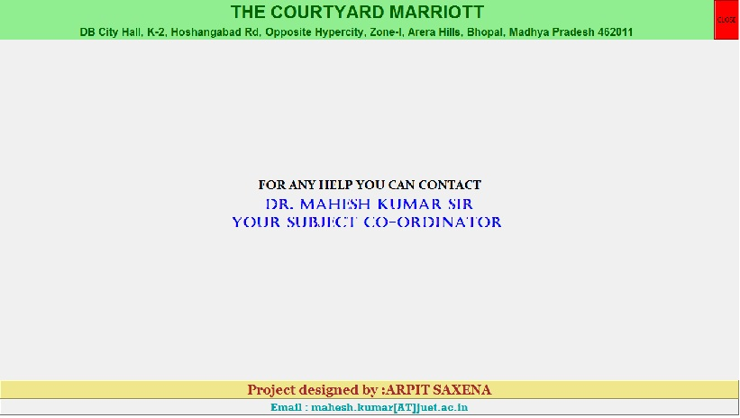
Now when we click on ABOUT US BUTTON:

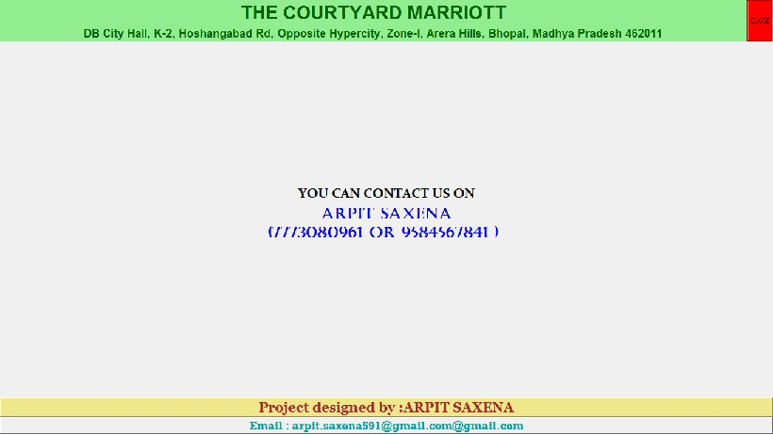

Now when we click on the EXIT BUTTON:

In the exit button i used the command “root.destroy” so it destroy my Tkinter.

Now the main part the ENTER BUTTON:
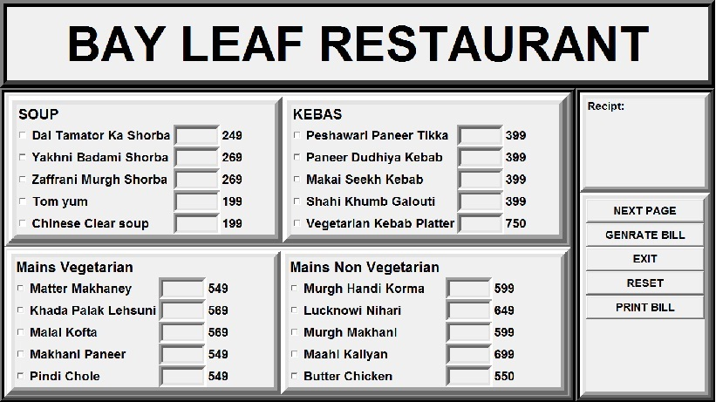
In this G.U.I I used:
a. Labels
b. Check button
c. Entry
d. Frames
e. Buttons

Labels in this GUI is used for assigning my dishes price and the heading of my page.

Check buttons is used for my dishes name and there is a textbox or we can say entry which is used to enter the quantity.
Currently it is disabled to enabled it you have to click on the dish name which is in the form of check button let us see:
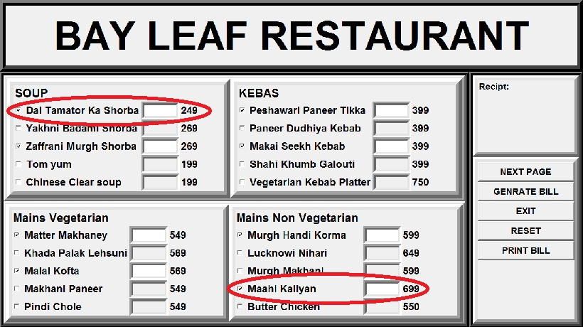
Buttons:

There are 5 buttons

a. Next Page
b. Generate Bill
c. Exit
d. Reset
e. Print Bill

Functioning of the Button:

1.Reset
it is used to reset every thing.
Let see:
Before Reset:
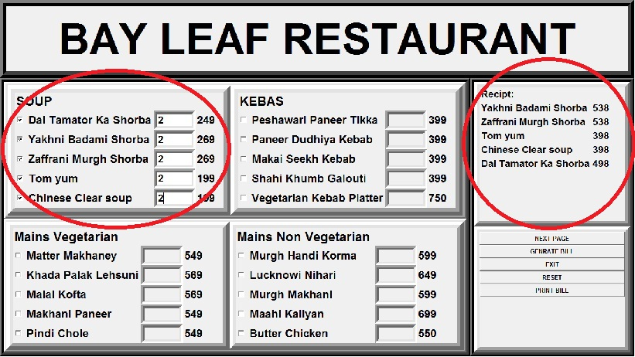
After Reset:
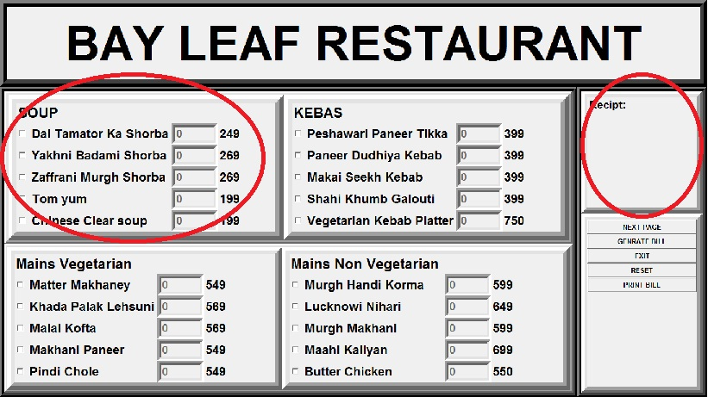

2.Genrate Bill:
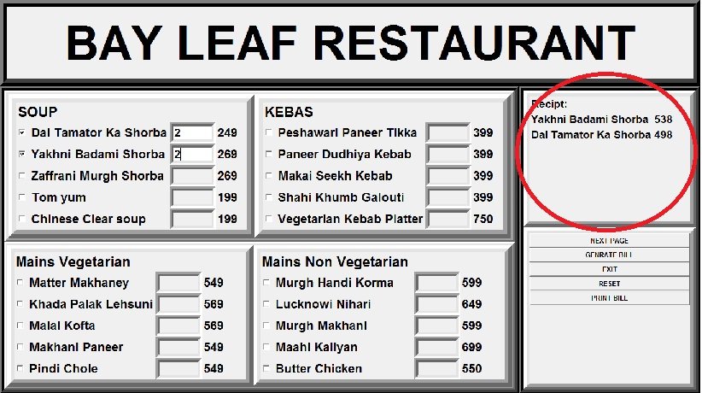

3.Print Bill:
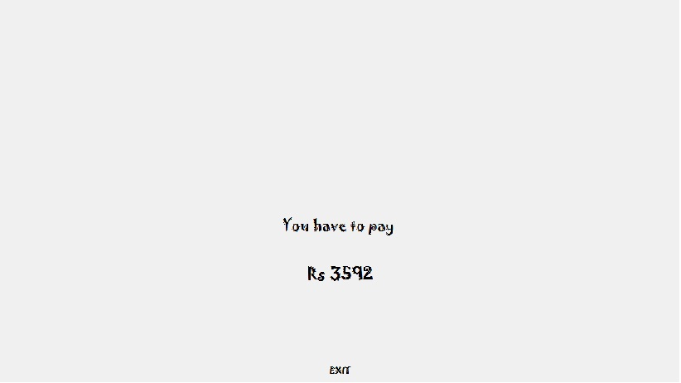

4.Exit:
5.Next Page:
when we click on the next page the menu get change.
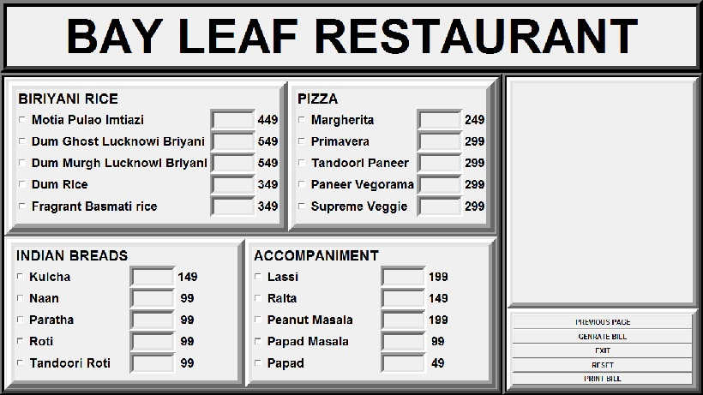

Second Page:
There are 5 buttons

a. Previous Button
b. Generate Bill
c. Exit
d. Reset
e. Print Bill

1.Previous Button:
when we click on the previous button the previous menu will appear.

2.Genrate Bill:
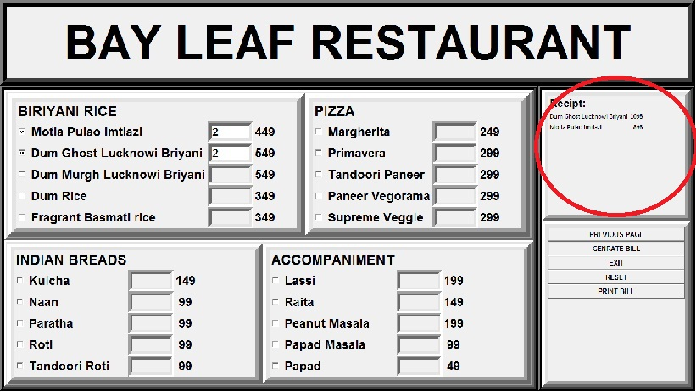

3.Print Bill

4.Reset:
